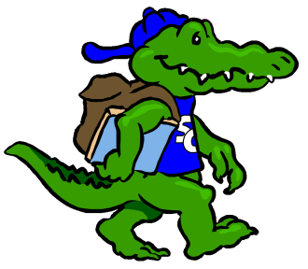
Sycamore Creek Elementary
Staff Profile
Name: |  |  | Grade: First Grade
Favorite Color? | I love all colors --- but probably French blue, yellow and red are my favorite
Favorite Flower? | Gerber daisies or tulips --- but I love any kind of flower
Favorite Food? | Italian and Asian
Favorite Fruit? | Rasberries & apples -- but I love all fruit
Favorite Drink? | Diet Snapple & Starbucks
Favorite Dessert? | Anything apple, lemon or chocolate
Do you like Candy? (What kind?) | Starbursts, jelly beans, skittles and dark chocolate
Favorite Restaurant? | Maggianos, Olive Garden, Panera, PF Chang’s, Chick Fil A
Favorite Store? | Target, Kohl’s, Barnes and Nobles, Amazon
If you could receive a gift card, what store would you like? | Any of them
Hobbies? | Bike, hike and read (when I can)
Things you like? | I love to laugh and get together with friends and family
Any dislikes? | Unkind words

Items Needed for Our Classroom
Books for our library |  | Treats for the class store
Bright colored copy paper |  | Art supplies

