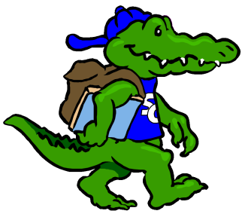
Sycamore Creek Elementary

Staff Profile
Name: Angela Scott |  | Grade: 1st
Favorite Color? | Lime green and hot pink
Favorite Flower? | Gerber Daisy
Favorite Food? | Mac n cheese, cheeseburgers, chicken fingers, pizza and pizza logs
Favorite Fruit? | Strawberries, apples, watermelon, cantaloupe, peaches, pears, and blueberries
Favorite Drink? | Crystal Light Strawberry packets and Dr.Pepper
Favorite Dessert? | Chocolate chip cookies, ice cream, ice cream cake
Do you like Candy? (What kind?) | Kit Kats, m&ms, Skittles, Necco’s
Favorite Restaurant? | Chick-fil-et, Jason’s Deli, Subway, Maggiano’s
Favorite Store? | Target, Hobby Lobby, AC Moore, Michaels, Walmart
If you could receive a gift card, what store would you like? | Target, Hobby Lobby, AC Moore, Michaels, Teachers Pay Teachers
Hobbies? | Camping, hanging with my lil fam, arts and crafts, finding neat lessons for class

Items Needed for Our Classroom
Pastel/Neon colored cardstock |  | Pastel/Neon colored copy paper
Candy for class store |  | Art supplies
Themed sticker books |  | Shipping labels
Colored ink HP97 |  | Sheet protectors

